SUIT reference protocol RP2mt
O2k high-resolution respirometry

2016-08-17

D+mt: NFSGpTm_1D 2Oct 3M 4c 5P 6G 7S 8Gp 9U 10Rot 11Ama 12Tm 13Azd

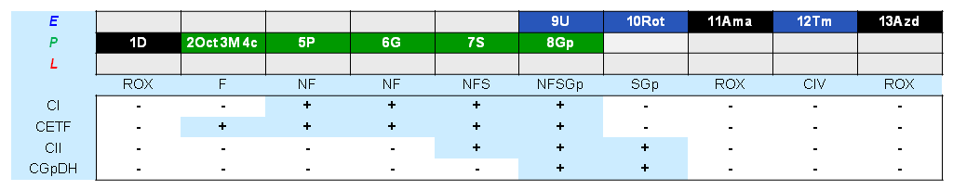

O2k and DatLab file: P___ ( A / B ) 2016- Operator:
Sample type: Cohort: Sample code:
Sample.Subsample number: Unit: Concentration:
Medium:
Event | Mark name | State | Final conc. 2 ml O2k | Stock  [mM] | Comment | Tit.  [µl] | A | B
MiR
O2 |  |  | ~200 µM |  | ~450 µM for pfi
D | 0 |  | 2.5 mM | 500 | 7.5 mM (30 µl) for pfi | 10
mt
O2 | 1D | ROX | ~200 µM |  | ~450 µM for pfi
Oct | 2Oct | Oct | 0.5 mM | 100 |  | 10
M.05 | 3M.05 | Oct_{P} | 0.05 mM | 50 |  | 2
M.1 | 3M.1 | Oct_{P} | 0.1 mM | 50 |  | 2
M2 | 3M2 | Oct_{P} | 2 mM | 400 |  | 9.5
c | 4c | Oct_{Pc} | 10 µM | 4 | NADH only if FCF_{c} >.1 | 5
P | 5P | PMOct_{P} | 5 mM | 2000 |  | 5
G | 6G | PGMOct_{P} | 10 mM | 2000 |  | 10
S | 7S | PGMSOct_{P} | 50 mM | 1000 |  | 100
Gp | 8Gp | PGMSOctGp_{P} | 10 mM | 1000 |  | 20
U | 9U | PGMSOctGp_{E} | Δ0.5 µM | 1 | CCCP | Δ1
Rot | 10Rot | SGp_{E} | 0.5 µM | 1 |  | 1
Ama | 11Ama | ROX | 2.5 µM | 5 |  | 1
As |  |  | 2 mM | 800 |  | 5
Tm |  |  | 0.5 mM | 200 | ~20 min open, C | 5
C | 12Tm | Tm_{E} |  |  | ~450 µM O₂ for pfi, C
Azd | 13Azd | ROX | ≥100 mM | 4000 | ~5 min | 100

