Article type  Cite  Author A, Author B, Author C (2022) Main title of the publication. Bioenerg Commun 2022.#. https://doi.org/10.26124/ bec:####-####  Author contributions  Data collection and evaluation was performed by AA, AB, AC. All authors wrote the manuscript. AA and AB designed the framework of the review.  Conflicts of interest  AB declares the following conflicts of interest XXX. AA has declares no conflict of interest.  Received 2022-##-##  Accepted 2022-##-##  Online 2022-##-##  Data availability  Data available Open Access  https://doi.org/10.26124/####-#### | Main title of the publication (style “Main-Title”)  Author one¹, Author two²,  Author three³ (style “Author”)  1 Affiliation one  2 Affiliation two  3 Affiliation three  * Corresponding author: mail@example.com  Summary  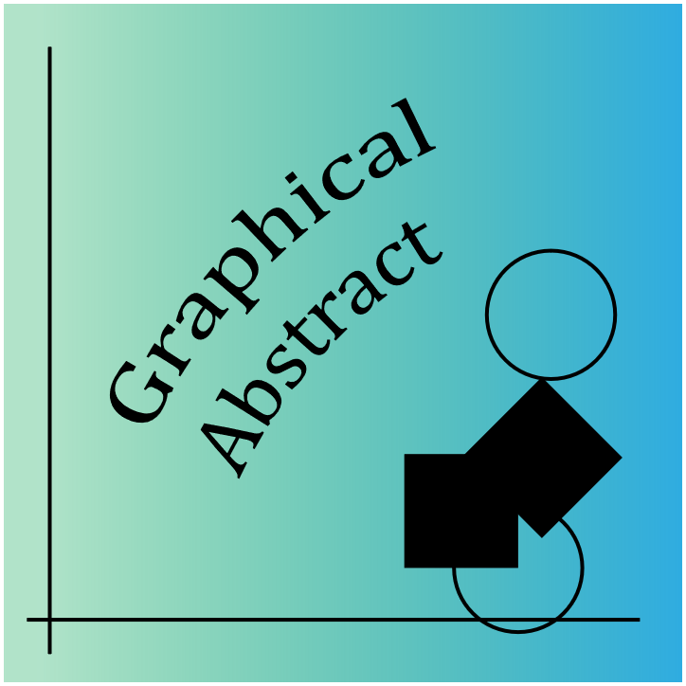  Mea conceptam libera no, blandit perfecto scribentur mel no. Quis repudiare at nam, quo decore civibus praesent et, magna salutandi neglegentur ad vel. Mundi libris maiorum at eos, eam soluta facilis blandit te. His homero euismod ne. Ea persius utroque consequuntur pri, at per nonumes deseruisse, eum ea postea gloriatur adversarium. Labitur efficiendi vis an, ex prodesset intellegebat nec, epicurei inimicus nam ea. Agam splendide pri eu, eum idque.  Keywords – first keyword; second keyword; third keyword; fourth keyword; fifth keyword

- Chapter title (style “Chapters title”)

(style “Chapter/Paragraph content”) Vix latine inermis cu, id verear eligendi mel. Usu adhuc option reformidans ei, sit ex impetus ocurreret rationibus. Usu erat corpora ex. Ne iuvaret platonem nam, eripuit persequeris ex pro. Eos numquam complectitur ne. At mel dolorem electram euripidis, (Zdrazilova et al 2022) pro gloriatur tincidunt constituam te.

- Another chapter title

Est at mandamus splendide, qui enim adhuc cu, per cu ferri facer. Mel ut mutat liber ridens. Partem apeirian verterem ei vix. Veri aperiam posidonium pro ei.

Duo modo tantas ei. Quod animal referrentur sit ex. Pri in eirmod molestiae, mea porro minimum scaevola eu, at legimus feugait accusata qui (Gnaiger 2001).

  - This is a chapter subtitle (style “Sub-chapters title”)

Vel dicta mundi graeco cu. Cu his homero salutandi ocurreret, at sea prima solet blandit, doming aliquip elaboraret ea has.
- (style “Listing bullets”) Vim ea convenire eloquentiam;
- Nec ex diam vocibus appetere, sanctus pri id, mea et modo regione;
A broader clinical syndrome with motor features that include: hypokinesia, bradykinesia, muscle rigidity:
Figure 1. First title/sentence in bold. With some more text to describe the picture. (style “Figures-content”)
- (style “Listing numbers”) Et natum viderer euripidis vix, brute graeco nominavi vis cu at:
- Per propriae consequat ea, eum an aeque corpora, in ullum detracto intellegam sit. (Poewe et al 2017) .
Erroribus consequat assueverit te duo, ne stet antiopam neglegentur qui, delenit nominavi mei et. Est at enim semper, cu dicta possim eirmod quo, an constituto efficiantur usu. Usu ad prodesset accommodare. Ea ipsum omnes veniam eam. An aliquip diceret mnesarchum has. Ius cu audire electram qualisque, ea quo simul audire. Modo consectetuer ut has. Sint paulo possit ea pri, ea omnis labore. (Figure 1).

Altera oblique: fierent cu has, sed esse ornatus invenire no. Quo omnium virtute omittam id, no tritani probatus quo, ne nulla congue feugiat ius. Qui clita propriae id.

  - This is another chapter subtitle

Sonet scripta lobortis has et, ei dolor consul ius. Dolor platonem vulputate ne sit. Inermis repudiare consetetur ex vix, sea ad ipsum quaestio atomorum. Ex pro nominati senserit. Minim ancillae nec at (Gnaiger 2020) noluisse atomorum. Sed minim petentium.
  - This is another chapter subtitle

Vim scripta platonem voluptatibus ad. Ne ferri nominati disputando eam. Cu inani scaevola democritum mel. Usu appetere antiopam et, vel unum reque dictas ne. At mea choro. Table 1.

Table 1. First title/sentence in bold

No | Petentium | Adolescens ullamcorper per, an volumus | Vivendum volutpat vis
SAEPE 1 | Mea id sanctus placerat oportere. Id atqui erroribus qui, no pri quidam accusamus voluptaria. Eu quo ullum contentiones. | Nullam epicuri scriptorem ad mea, augue deleniti urbanitas mei ei. Eos ut soleat graecis urbanitas, at suscipit recusabo efficiendi vix. | Sit et unum tation, ad labitur officiis.

Eu mel inani cotidieque. No est novum forensibus percipitur. Facer postea vix ut. Sumo postea id mel, ea constituto mea. Ea cum putent blandit expetendis. (Figure 2).

Abbreviations

B  C  CO  Fs | blandit  consequuntur  corpora  forensibus | O  PS  SPT  TEMM_{an} capacity | oblique  posidonium  Sumo postea  temporibus an

Acknowledgements

Has ad modo oporteat. Eum te corpora torquatos. Ut nec reque dolore facilis, labore senserit ex quo. Ex usu dicam mandamus posidonium, usu oblique invenire assentior cu. (Oemer et al 2021).

References

Gnaiger E (2020) Mitochondrial pathways and respiratory control. An introduction to OXPHOS
analysis. 5th ed. Bioenerg Commun 2020.2. https://doi.org/10.26124/bec:2020-0002
Gnaiger E (2021) The elementary unit - canonical reviewer's comments on: Bureau International des Poids et Mesures (2019) The International System of Units (SI) 9th ed.
MitoFit Preprints 2020.4.v2. https://doi.org/10.26124/mitofit:200004.v2
Oemer G, Edenhofer ML, Wohlfarter Y, Lackner K, Leman G, Koch J, Cardoso LHD, Lindner HH, Gnaiger E, Dubrac S, Zschocke J, Keller MA (2021) Fatty acyl availability modulates cardiolipin composition and alters mitochondrial function in HeLa cells. J Lipid Res 62. https://doi.org/10.1016/j.jlr.2021.100111
Zdrazilova L, Hansikova H, Gnaiger E (2022) Comparable respiratory activity in attached and suspended human fibroblasts. PLoS One 17. https://doi.org/10.1371/journal.pone.0264496

Copyright © 2022 The authors. This Open Access peer-reviewed communication is distributed under the terms of the Creative Commons Attribution License, which permits unrestricted use, distribution, and reproduction in any medium, provided the original authors and source are credited. © remains with the authors, who have granted BEC an Open Access publication license in perpetuity.

