SUIT reference protocol RP2pce

O2k high-resolution respirometry

Version: 2016-11-19

FNSGp(PGM)02_pce_1D(M.1),2Oct,3M2(c),4P,5G,6S,7Gp,8U,9Rot,10Ama,11Tm,12Azd
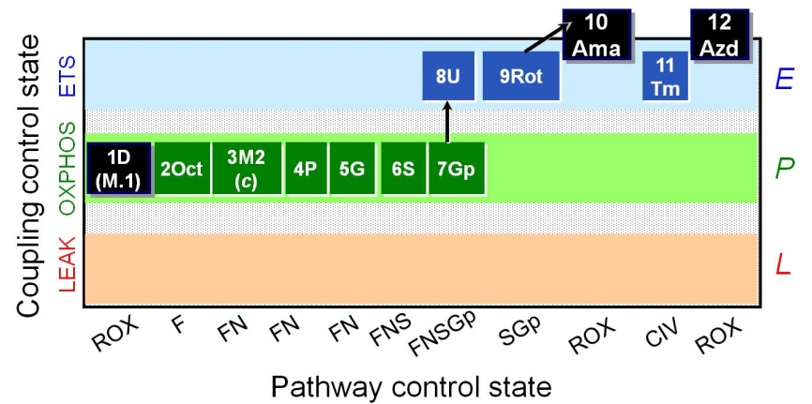

O2k and DatLab file: P___ ( A / B ) 2016- Operator:
Sample type: Cohort: Sample code:
Sample.Subsample number: Unit: Concentration:
Medium: MiR06Cr
Event | Mark name | State | Final conc.  2 ml O2k | Stock  [mM] | Comment | Tit.  [µl] | A | B
MiR
O2 |  |  | ~200 µM
ce | R | R
Dig | Dig |  |  | 8.1
D | 1D | ROX | 1 / 2.5 mM | 500 |  | 4 /10
M.1 | (M.1) |  | 0.1 mM | 50 |  | 4
Oct | 2Oct | MOct_{P} | 0.5 mM | 100 |  | 10
M2 | 3M2 | MOct_{P} | 2 mM | 400 |  | 9.5
c | M(c) | MOct_{Pc} | 10 µM | 4 | NADH only if FCF_{c}>.1 | 5
P | 4P | PMOct_{P} | 5 mM | 2000 |  | 5
G | 5G | PGMOct_{P} | 10 mM | 2000 |  | 10
S | 6S | PGMSOct_{P} | 50 mM | 1000 |  | 100
Gp | 7Gp | PGMSOctGp_{P} | 10 mM | 1000 |  | 20
U | 8U | PGMSOctGp_{E} | Δ0.5 µM | 1 | CCCP | Δ1
Rot | 9Rot | SGp_{E} | 0.5 µM | 1 |  | 1
Ama | 10Ama | ROX | 2.5 µM | 5 |  | 1
As |  |  | 2 mM | 800 |  | 5
Tm |  |  | 0.5 mM | 200 | ~20 min open, C | 5
C | 11Tm | Tm_{E}
Azd | 12Azd | ROX | ≥100 mM | 4000 | ~10 min | 100

